1. The IP address of the IP trace file given is 192.168.102
2. The upper layer protocol field value is: ICMP (1)
3. 20 bytes are in the header – 84 bytes in length means we have a 64-byte payload
4. It has not, the flag for more fragments is not set under the flags dropdown
5. Identification, header checksum, and the time to live seem to always change
6. Constant fields: Source IP, Destination IP, upper layer protocol, differentiated services, header length, and version
   1. The fields that need to change are: Identification, because the packets must have different IDs, the header checksum, because the header can change, so checksum must be able to as well. The final thing is the Time to Live, where the traceroute can increment for each subsequent package
7. I notice that the IP header id fields increase with each of the icmp ping requests
8. Id field: 42507 TTL field: 244
9. Id field will change because it’s a unique value, if they have the same, then they are fragments of a larger IP datagram. TTL should be unchanged because the TTL for the first hop is always the same
10. Yes, that packet has been fragmented across multiple IP diagrams

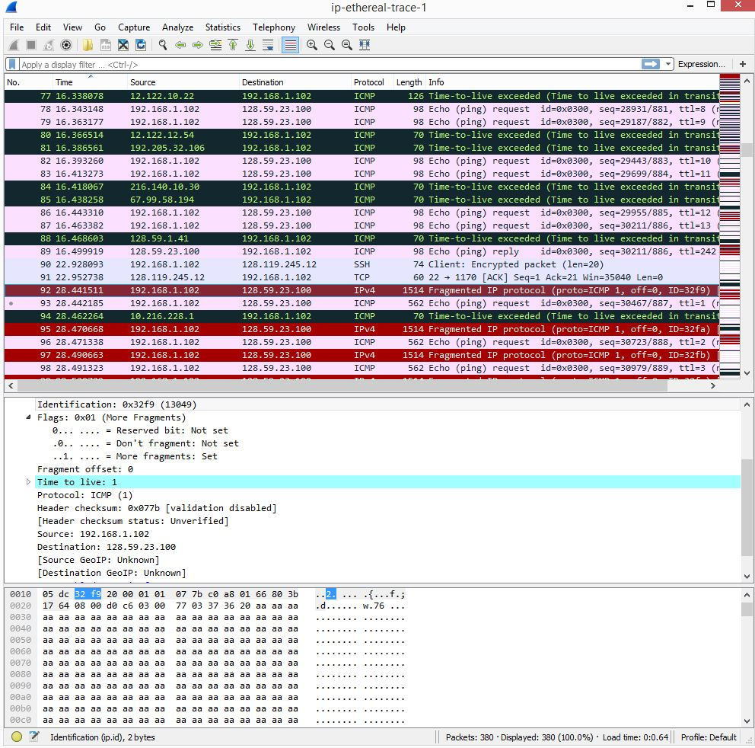

* 1. The fragment flag is set, telling us that this is fragmented, and it looks like this datagram has a length of 1500, including the header

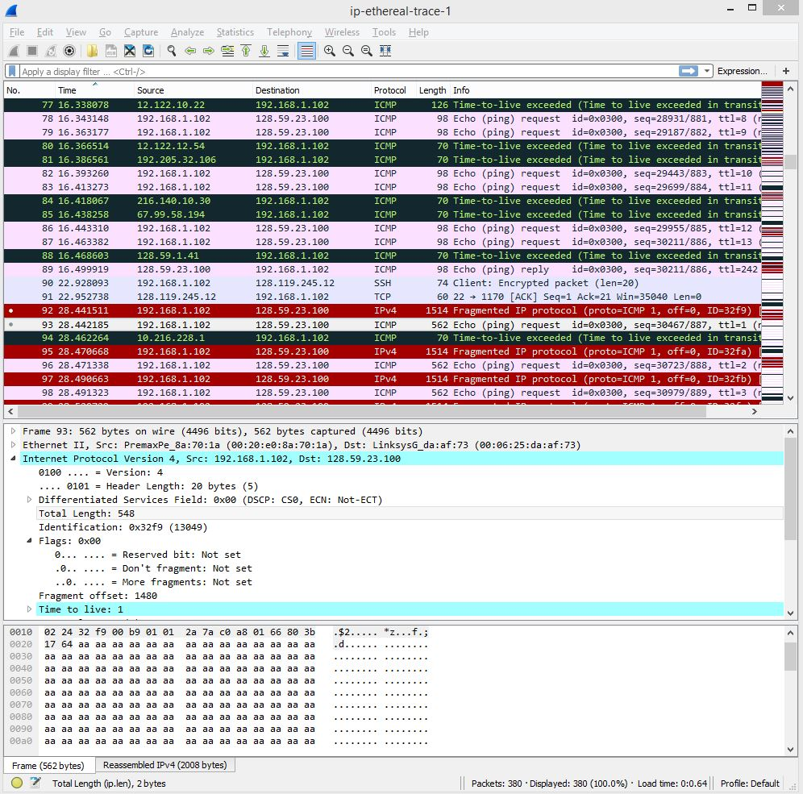

* 1. The fragment offset is 1480, so we know it is fragmented, and it is the last fragment because the more fragments flag is not set

1. The fields that changed between fragments are the checksum, flags, fragment offset, and the total length
2. After switching to 3500, 3 packets are created from the original datagram
3. The IP header fields that changed were: checksum, and fragment offset. There is also a change in the flags, and the total length of the packets, the first two have a size of 1500 after the increase, and the more fragments were both set to 1, while the last one had a length of 540 with 0 more fragments set.